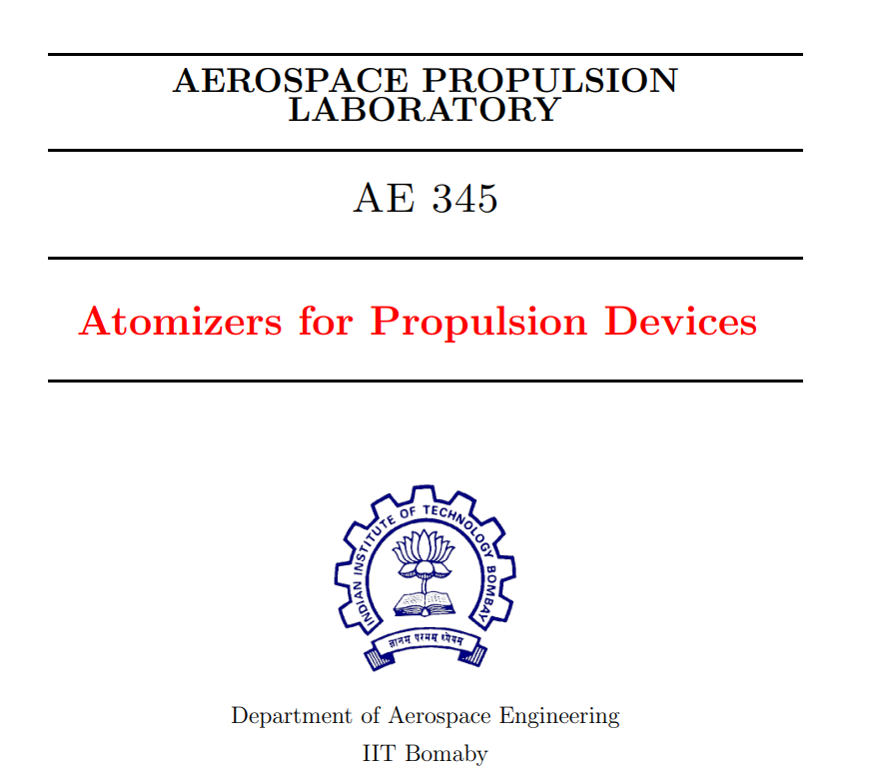
ADITYA KUMAR | 22B0053

THEORY
Injectors are critical components in propulsion systems, responsible for delivering and atomizing fuel and oxidizers into the combustion chamber. Their primary function is to break the liquid fuel into fine droplets, ensuring efficient mixing with the oxidizer, which is essential for effective combustion. By creating a controlled spray pattern, injectors help optimize the combustion process, leading to better engine performance and reduced emissions. Different types of injectors are used depending on the application, such as Air-blast injectors in gas turbines and Gas-Centered Swirl Coaxial (GCSC) injectors in rocket engines.
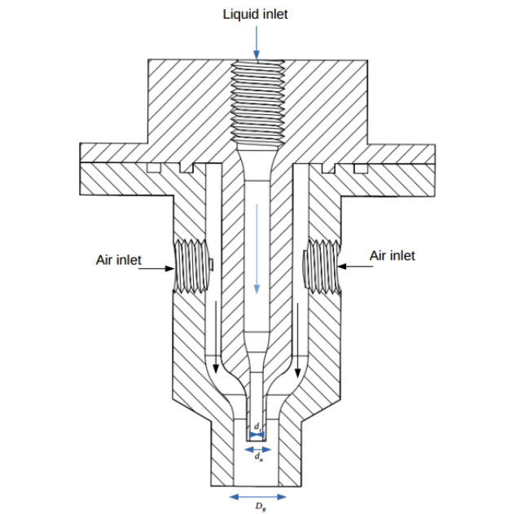
- Air – Blast Injector:
Air-blast injectors work by using a high-velocity air stream to atomize liquid fuel. The fuel is introduced at low pressure and encounters the fast-moving air, which shears the liquid into fine droplets. This process increases the surface area of the fuel, promoting better mixing with air and more efficient combustion. The result is enhanced fuel atomization even at low pressures, leading to improved engine performance.

- Gas-Centered Swirl Coaxial Injector (GCSC):
Gas-Centered Swirl Coaxial (GCSC) injectors work by injecting a high-velocity gas stream through the center, surrounded by a coaxial flow of liquid fuel. The central gas stream induces a swirling motion in the liquid as it exits the injector, enhancing atomization into fine droplets. This swirl ensures thorough mixing of the fuel with the oxidizer, optimizing combustion efficiency. GCSC injectors provide precise control over fuel and oxidizer interactions, making them ideal for high-performance applications like rocket engines.
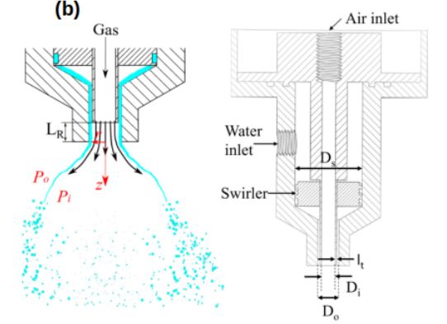
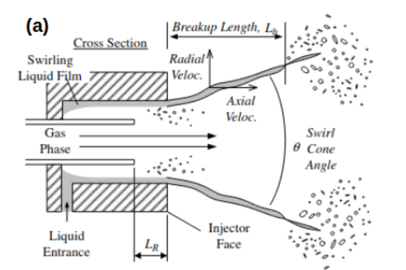
- Breakup Length Plot:
Breakup Length(mm) | Water(lpm) | Air(lpm)
110.659 | 0.4 | 0
74.036 | 0.4 | 14
53.25 | 0.4 | 26
32.051 | 0.4 | 36
35.177 | 0.4 | 40
22.394 | 0.4 | 50
183.633 | 1 | 0
169.618 | 1 | 20
152.751 | 1 | 26
111.901 | 1 | 36
51.285 | 1 | 46
24.466 | 1 | 60
14.472 | 1 | 80
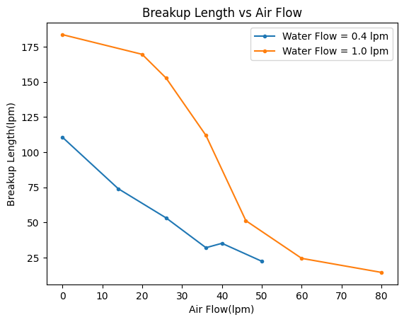
Breakup length refers to the distance a liquid jet travels before it disintegrates into droplets due to aerodynamic forces. This is a key parameter in injector design, as it influences how effectively the fuel is atomized and mixed with air or oxidizer.

- MFR vs Cone Angle:
MFR is the ratio of gas momentum flux to liquid momentum flux at the exit of the injector.
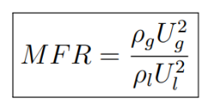
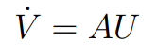
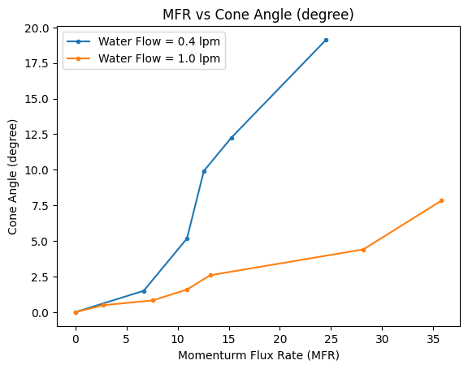
Water(lpm) | Air(lpm) | MFR | Cone Angle(º)
0.4 | 0 | 0.0 | 0.0
0.4 | 14 | 1.50065 | 6.69
0.4 | 26 | 5.175625 | 10.921
0.4 | 36 | 9.9225 | 12.572
0.4 | 40 | 12.25 | 15.25
0.4 | 50 | 19.140625 | 24.52
1 | 0 | 0.0 | 0
1 | 20 | 0.49 | 2.77
1 | 26 | 0.8281 | 7.592
1 | 36 | 1.5876 | 10.921
1 | 46 | 2.5921 | 13.18
1 | 60 | 4.40999 | 28.16
1 | 80 | 7.84 | 38.80

- MFR Calculation:
V_{g} = 14 lpm = 14*(60000)⁻¹ m³/s V_{l} = 0.4 lpm = 0.4*(60000)⁻¹ m³/s
U_{g} = V_{g}/(3.14*0.007²/4) m/s U_{l} = V_{l}/(3.14*0.007²/4) m/s
MFR = $\frac{rho\left(gas\right)*\left\{U\left(gas\right)\right\}*\{U\left(gas\right)\}}{rho\left(fuel\right)*\{U\left(fuel\right)\}\{U\left(fuel\right)\}}$ = 1.500625
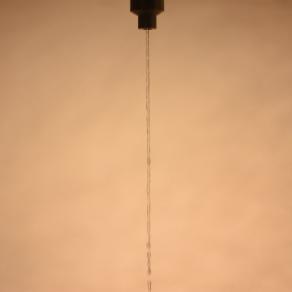 | 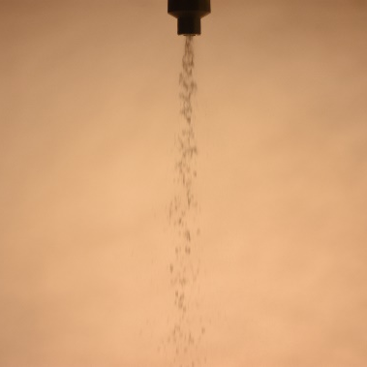 | 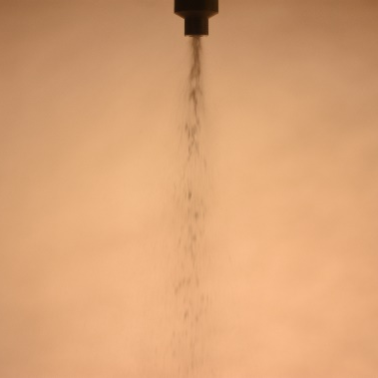 | 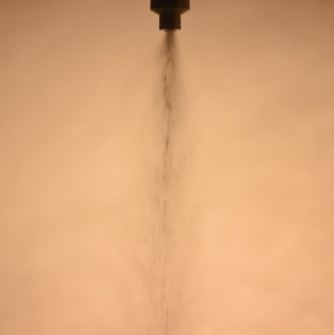
MFR = 0.0 | MFR = 1.58 | MFR = 4.40 | MFR = 7.84
- Different Regimes in Air Blast Injector:

- Observations:
The experiment was conducted at room temperature (25°C) and standard atmospheric pressure (101325 Pa). The liquid fuel was supplied at a constant flow rate, while the air flow rate was varied from 0 to 80 lpm. The air flow rate was gradually increased in increments from 0 lpm to 80 lpm, and the corresponding breakup length of the liquid jet was measured at each step.
Initially, with no air flow, the fuel exited the injector as a continuous stream, showing minimal atomization and a longer breakup length. As the air flow rate increased, there was a noticeable reduction in breakup length, marking the onset of improved atomization. Further increases in air flow continued to decrease the breakup length, resulting in finer droplet formation and a more uniform spray pattern. At the highest air flow rates tested, the breakup length reached its minimum, demonstrating the most efficient atomization and the finest droplet formation observed during the experiment.
Anomalies: There were slight irregularities in the trend of breakup length reduction at 40 lpm air flow rates, likely due to flow disturbances, as the flow was highly dynamic, and the image was captured during a moment of instability.

- Conclusion:
The experiment showed a clear correlation between increasing air flow rate and improved atomization, as evidenced by the decreasing breakup length. The Air-blast injector effectively produced finer droplets and a more uniform spray pattern at higher air flow rates, demonstrating its capability to enhance fuel atomization with increased air velocity.
They are also employed in industrial burners and afterburners, where precise control over the fuel-air mixture is essential for maintaining high combustion efficiency and reducing emissions.

